Reporting Aggregated Data Using the Group Function
1.Find the highest , lowest, sum and average salary of all employees. Lable the columns.
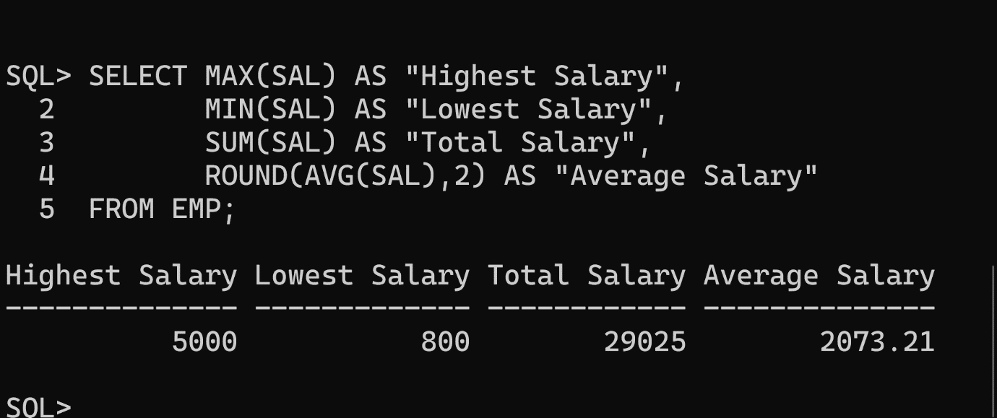
2.Maximun, Minimum, Sum, and Average, respectively. Round your results to the nearest whole number.

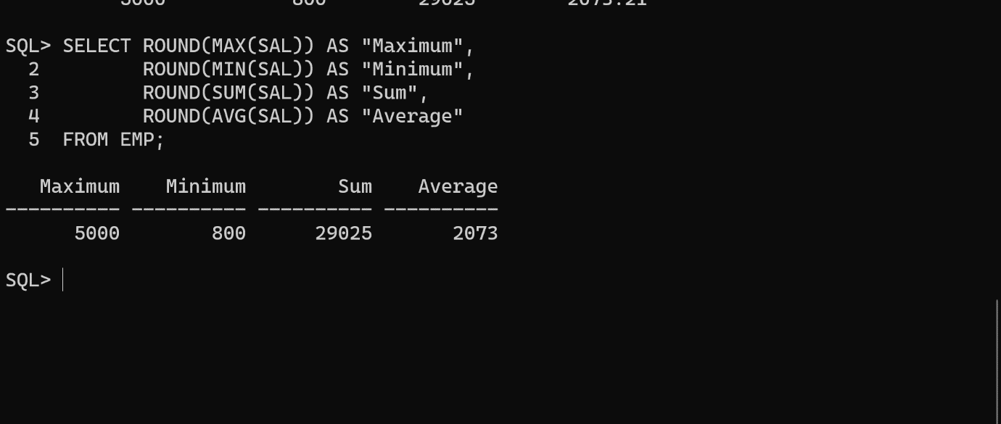

3.Modify the above query to display the minimum, maximum, sum, and average salary for each job type.
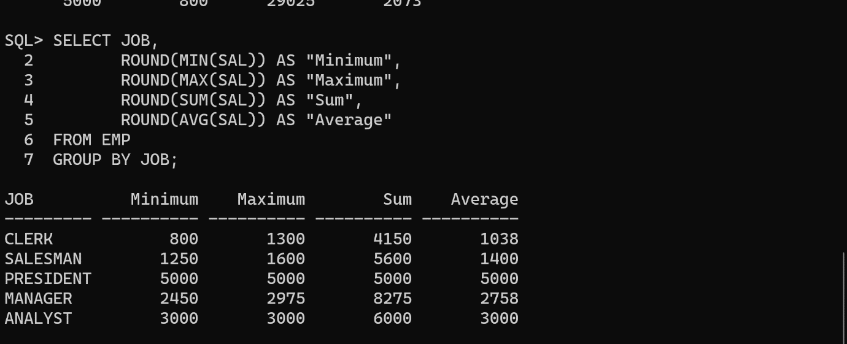
4. Write a query to display the number of people with the same job.
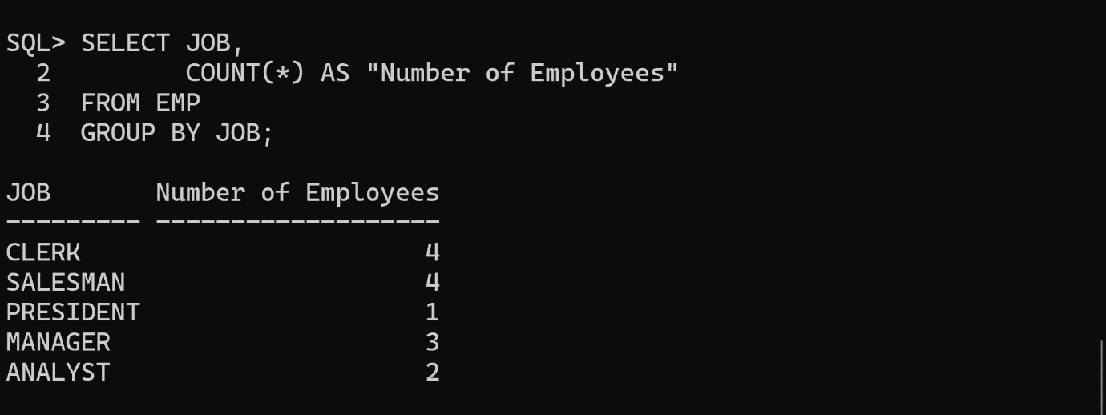
5.Determine the number of managers without listing them. Lable the column Number of Managers.


6.Find the difference between the highest and lowest salaries. Label the column DIFFERENCE.
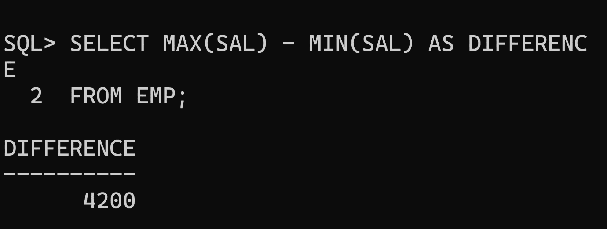

7.Create a report to display the manager number and the salary of the lowest-paid employee for that manager. Exclude anyone whose manager is not known. Exclude any groups where the minimum salary is $2000 or less.Sort the output in descending order of salary.
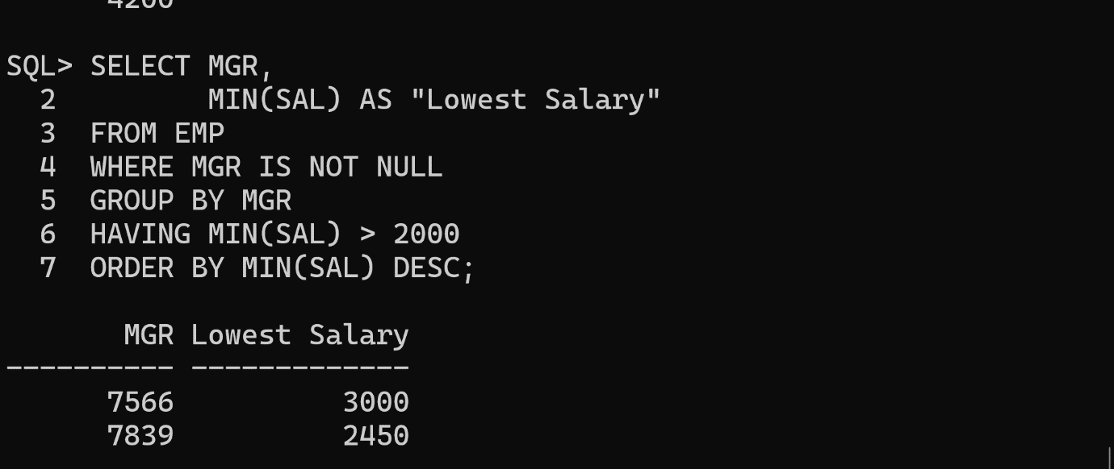

8.Create a query to display the total number of employees and, of that total, the number of the employees hired in 1980,1981and1982.Create appropriate column headings.
